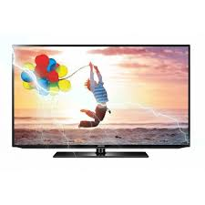

Samsung EH5000

* Digital Dolby Plus
* Energy Efficiency:A
* 10W X 2 Sound Output
* Size 32 Inch
* **Rs. 35,499**